1. 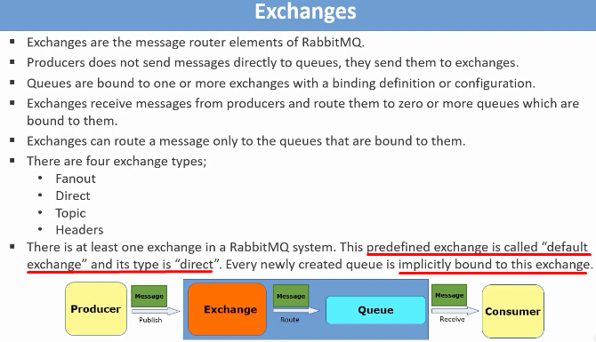
2. **NOTE**: Exchange to exchange binding is also available instead of binding exchange to queues. Such exchanges are for internal purpose inside RabbitMQ and their type is internal.